## Pune Vidyarthi Griha’s College of Engineering and technology and G K Pate(Wani) Institute of Management, Pune

**Savitribai Phule Pune University**



## Web Technology

**Mini Project: Design and implement a dynamic web application for any business functionality by using web development technologies that you have learnt in the above given assignments.**

## Prepared by,

|  |  |
| --- | --- |
| **Student Name** | **Roll no** |
| Shyam Lokhande | 036 |

**Under Guidance of Prof. B.C. Julme**

**Department of Computer Engineering Academic Year 2022-23**

# Table of content

|  |  |  |  |
| --- | --- | --- | --- |
| SR NO |  | Content | Page no |
| 1 |  | Abstract | 2 |
| 2 |  | Problem statement | 3 |
| 3 |  | Objectives | 4 |
| 4. |  | Introduction | 5 |
| 4.1 | Requirement Gathering | 5 |
| 4.2 | Development Methodology | 6 |
| 5. |  | Output | 9 |
| 6. |  | Conclusion | 12 |

## Abstract

This project aims to develop a website for ecommerce website that enables users to manage various aspects of their business. The website will provide a user-friendly interface that facilitates menu management, products order, payment interface, login user, and customer feedback. The website will incorporate features such as online ordering, payment processing, and marketing tools to enable business to grow their customer base and generate revenue. The website will be developed using modern web technologies, including HTML, CSS, JavaScript, Php, and various technologies and will be optimized for performance, accessibility, and search engine rankings. The project will help business owners and managers streamline their operations, reduce costs, and improve customer satisfaction.

## Problem statement

The business industry is highly competitive, with many business struggling to survive due to rising costs, changing consumer preferences, and intense competition. One of the key challenges facing business owners and managers is managing their operations efficiently and effectively. Many businesses still rely on manual processes and outdated technologies, which can lead to inefficiencies, errors, and customer dissatisfaction. In addition, the pandemic has highlighted the need for businesss to adopt digital solutions, such as online ordering and payment processing, to adapt to the changing market dynamics. Therefore, there is a pressing need for a modern, user-friendly, and comprehensive business management website that can help businesss overcome these challenges and thrive in the highly competitive business industry.

# Objectives

The objectives of the business management website project are as follows:

1. To provide a user-friendly interface for managing various aspects of business operations, including menu management, order reservations, staff management, and customer feedback.
2. To incorporate features such as online ordering, payment processing, and marketing tools to help businesss grow their customer base and generate revenue.
3. To develop the website using modern web technologies, including HTML, CSS, JavaScript, MySQL, and PHP, that are optimized for performance, accessibility, and search engine rankings.
4. To enable business owners and managers to streamline their operations, reduce costs, and improve customer satisfaction by using the website's comprehensive features.
5. To ensure that the website is secure and complies with industry standards and regulations for data privacy and security.
6. To provide ongoing technical support and maintenance to ensure that the website is updated and functioning optimally.

Overall, the objective of this project is to develop a comprehensive business management website that can help businesss overcome the challenges they face and thrive in the highly competitive business industry.

# Introduction

### Requirement Gathering:

The business industry is a crucial component of the global economy, generating significant revenue and employment opportunities. However, the industry is facing several challenges, including rising costs, changing consumer preferences, and intense competition. One of the critical factors that can determine the success of a business is its ability to manage its operations efficiently and effectively. Many businesss still rely on manual processes and outdated technologies, which can lead to inefficiencies, errors, and customer dissatisfaction.

To address these challenges, this project aims to develop a comprehensive business management website that can help business owners and managers streamline their operations, reduce costs, and improve customer satisfaction. The website will

incorporate features such as menu management, table reservations, inventory control, staff management, and customer feedback, to name a few. The website will also include online ordering and payment processing features, as well as marketing tools to help businesss grow their customer base and generate revenue.

The website will be developed using modern web technologies, optimized for performance, accessibility, and search engine rankings. By providing a user-friendly and comprehensive business management website, this project seeks to empower business owners and managers to take their businesses to the next level.

**Life-Cycle of Web Development Project:**

The life cycle of a web development project can be broken down into several stages:

1. Planning: The first stage of the web development life cycle involves defining the goals and objectives of the project. This includes identifying the target audience, understanding the requirements, and creating a project plan and timeline.
2. Design: Once the project goals and requirements are established, the next stage involves designing the user interface, visual design, and architecture of the website. This may include creating wireframes and mockups to visualize the layout and structure of the site.
3. Development: In the development stage, the website is built using programming languages such as HTML, CSS, and JavaScript. This involves creating the

functionality, database management, and server-side scripting required for the site to function.

1. Testing: Once the website is developed, it undergoes testing to ensure that it is functioning properly. This includes testing for bugs, errors, and usability issues. User acceptance testing may also be conducted at this stage to get feedback from users.
2. Deployment: After the website has been tested and approved, it is deployed to a live server where it is accessible to users.
3. Maintenance: The final stage of the web development life cycle involves ongoing maintenance and updates to ensure that the website remains functional and up-to-date. This includes fixing any bugs or errors that arise, updating content, and implementing new features or functionality as needed.

Throughout the web development life cycle, communication and collaboration between the development team and stakeholders is critical to ensure that the project is meeting the needs and requirements of all parties involved.

### Development Methodology:

Here's a brief description of each technology used for creating the complete website:

1. HTML: HTML (Hypertext Markup Language) is a markup language used for creating the structure and content of web pages. It provides a standard way to create web pages that can be viewed on different devices and platforms.
2. CSS: CSS (Cascading Style Sheets) is a stylesheet language used for describing the presentation of a web page. It provides a way to separate the presentation of a web page from its structure and content.
3. JavaScript: JavaScript is a programming language used for adding interactivity and dynamic functionality to web pages. It is used to create interactive forms, animations, and other dynamic elements on a web page.
4. MySQL: MySQL is a relational database management system used for storing and retrieving data. It is commonly used for web applications and can handle large amounts of data.
5. PHP: PHP (Hypertext Preprocessor) is a server-side scripting language used for creating dynamic web pages and web applications. It can interact with databases, process form data, and generate dynamic content based on user input.

Together, these technologies form the foundation for creating a modern, user-friendly, and efficient business management website. They provide a powerful toolset for creating dynamic web pages that are optimized for performance and usability, as well as for storing and retrieving data in a secure and efficient manner.

Here are the steps for creating a business management website:

1. Define the project scope and requirements: This involves identifying the goals and objectives of the website, the features and functionalities required, and the target audience.
2. Design the website structure and layout: This involves creating wireframes and mockups of the website, including the navigation, content layout, and user interface design.
3. Develop the front-end of the website: This involves writing HTML, CSS, and JavaScript code to create the user interface, including the menus, forms, and other interactive elements.
4. Develop the back-end of the website: This involves setting up a server environment, installing and configuring a web server, and creating a database to store the website's data.
5. Develop the website's functionality: This involves writing PHP code to implement the website's features, such as online ordering, payment processing, and customer feedback.
6. Test the website: This involves performing quality assurance testing to ensure that the website is functioning properly, is user-friendly, and meets the project requirements.
7. Deploy the website: This involves uploading the website to a web server and configuring it for production use.
8. Monitor and maintain the website: This involves regularly monitoring the website for performance and security issues and making updates and enhancements as necessary.

These steps are crucial for creating a high-quality and functional business management website that meets the needs of business owners and managers. It's

important to have a well-defined plan and to follow best practices for web development to ensure that the website is user-friendly, secure, and meets industry standards.

# Output

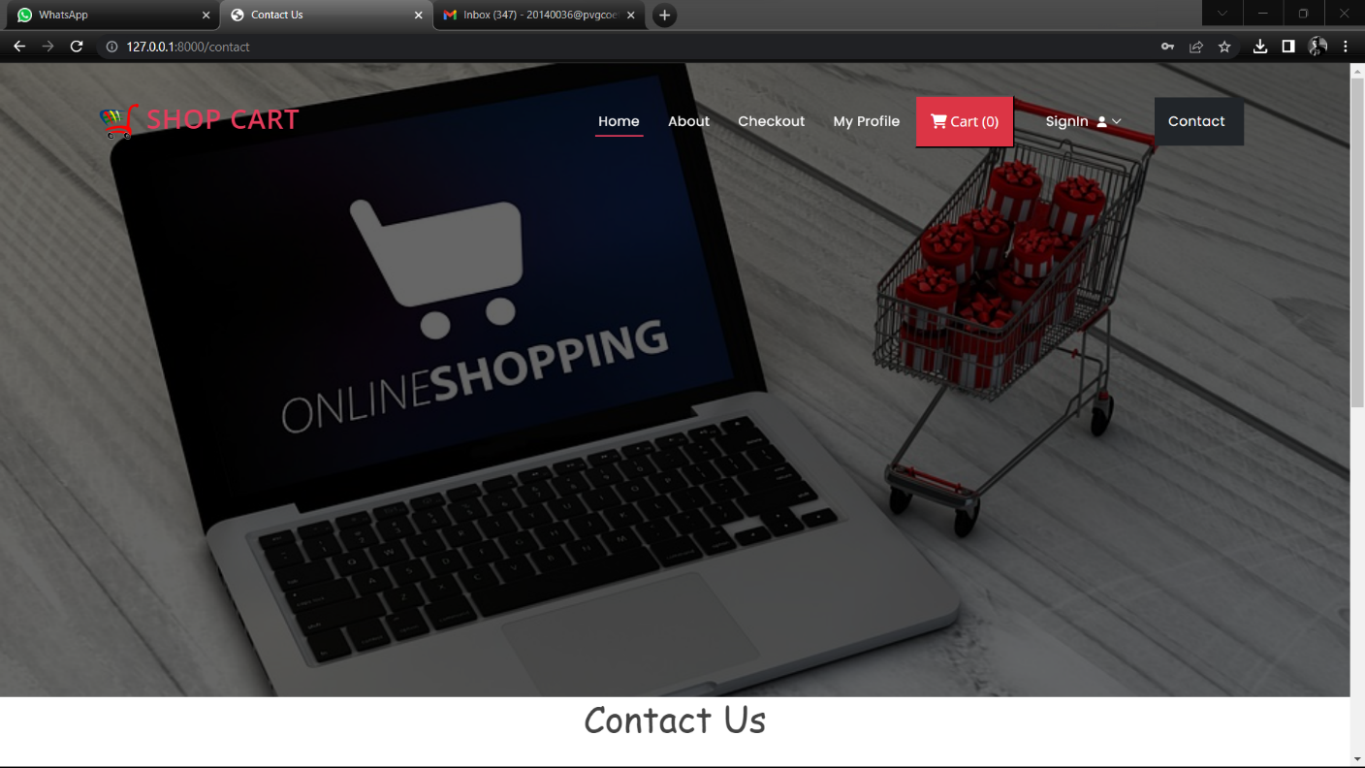

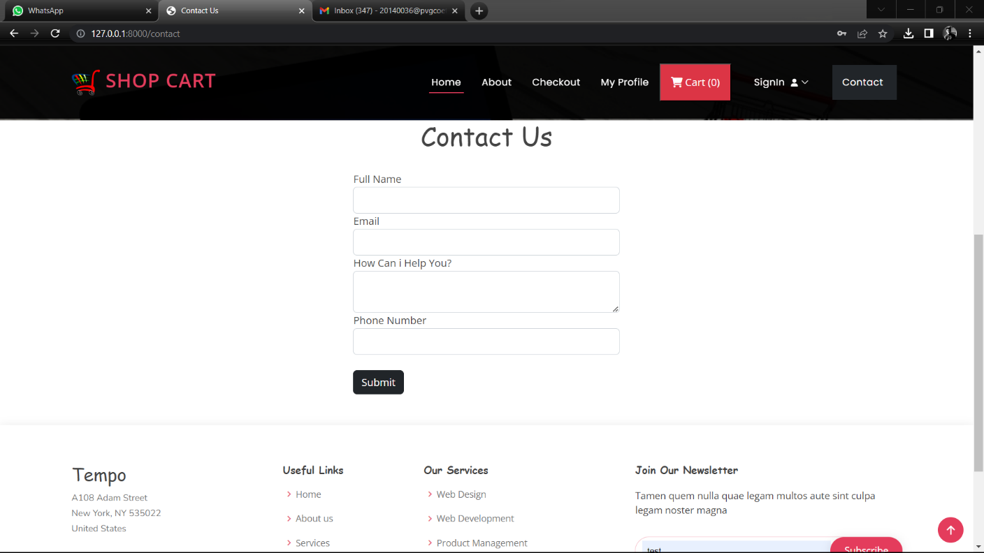

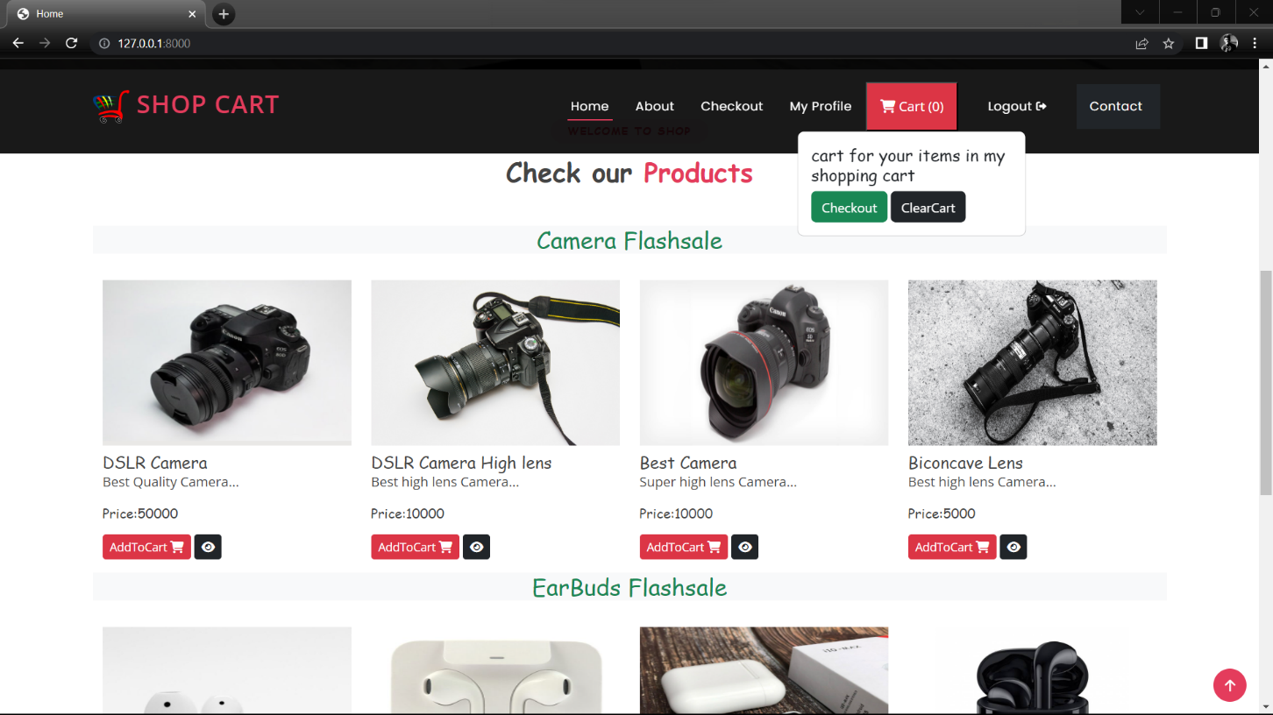

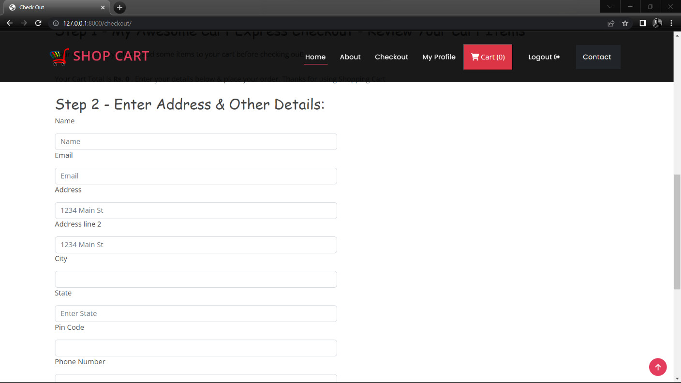

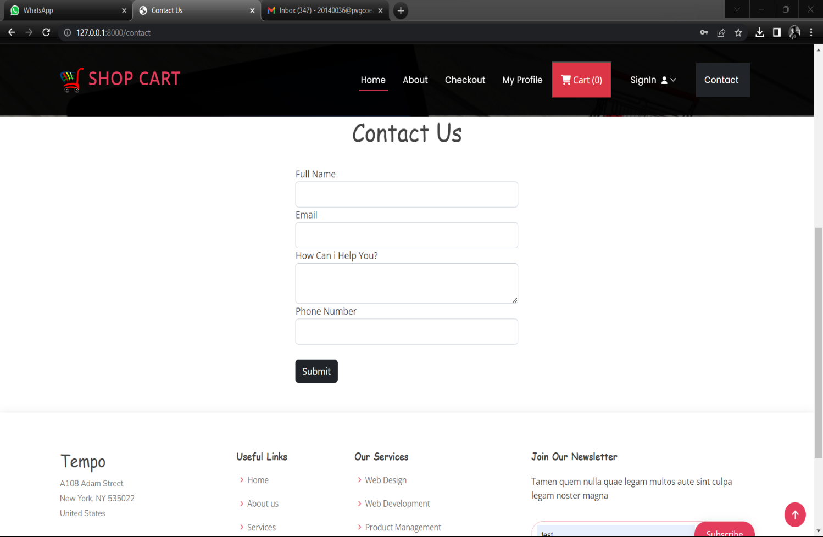

## Conclusion

In conclusion, the creation of a comprehensive business management website is crucial for business owners and managers to streamline their operations, reduce costs, and improve customer satisfaction. By leveraging modern web technologies such as HTML, CSS, JavaScript, MySQL, and PHP, this website can provide a range of features and functionalities such as online ordering, payment processing, staff management, and customer feedback, to name a few. Throughout the development process, it is essential to define project requirements, design and develop the front-end and back-end of the website, test the website, and deploy it to a web server. Additionally, it's important to provide ongoing technical support and maintenance to ensure the website remains up to date and functioning optimally.Overall, a well-designed and developed business management website can help business owners and managers overcome the challenges they face and thrive in the highly competitive business industry. It can provide a platform to enhance the customer experience, increase revenue, and improve overall efficiency.